**C844 Task 1**

1. **Network Topology**

My results from the nmap scan on the 10.168.27.0/24 network block shows the network has 6 hosts that make up a star(hub-and-spoke) network topology. This means that all hosts are connected by a centralized switch.

Screenshots of running nmap.

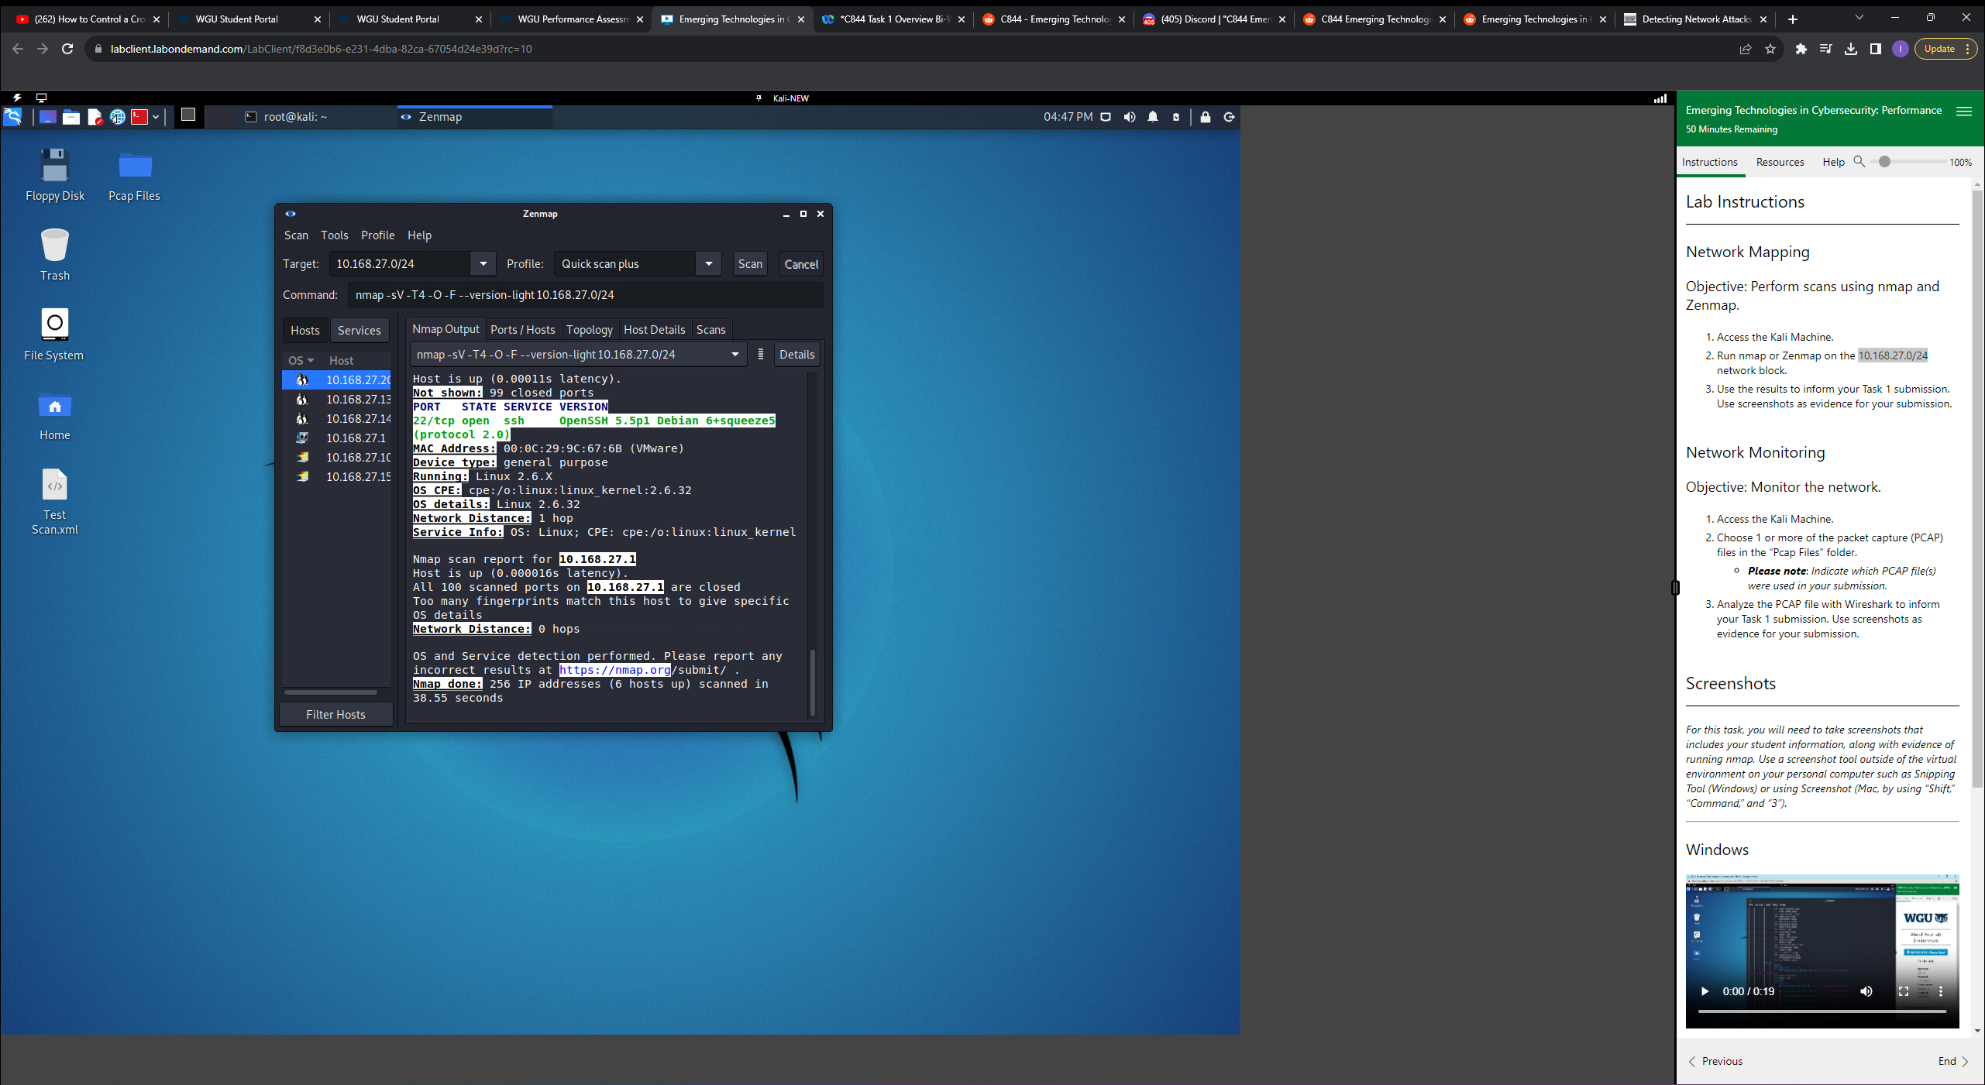

Screenshot of Zenmap Topology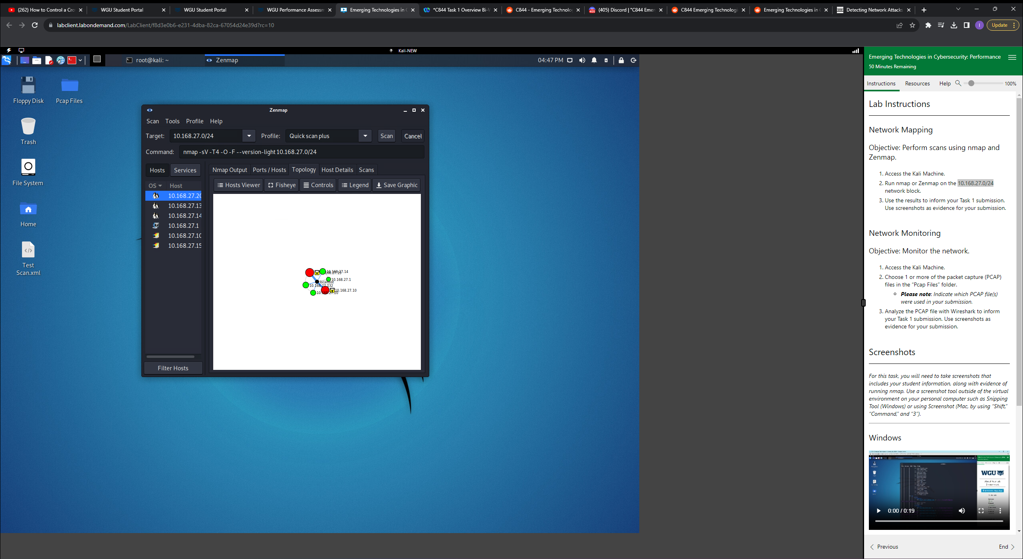

**B Summary of Vulnerabilities and Implications**

**First vulnerability**

The host 10.168.27.15 is running FileZilla over port 21 using FTP. The FTP protocol sends data in the clear over plaintext, making it easy for attackers to read confidential data.

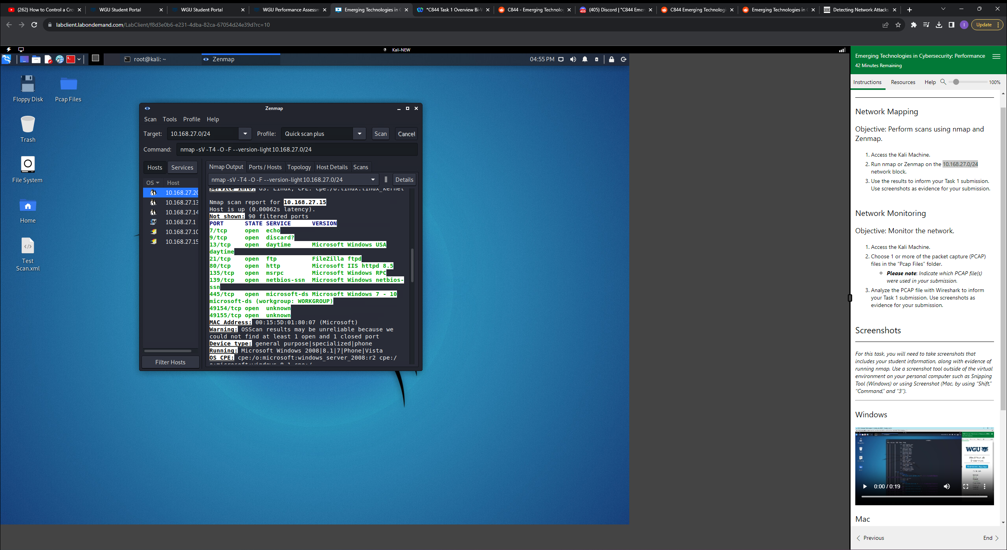

**Second vulnerability**

The host 10.168.27.15 also has an outdated OS, Windows Server 2008. This OS is no longer supported and opens the host to being exploited by attackers using known vulnerabilities.



**C. Wireshark Anomalies**

**First Anomaly**

The host 10.168.27.10 was sending and receiving data to and from 49.12.121.47 using FTP over port 21. The Host 49.12.121.47 is not a part of the local network and could be an attacker. The FTP protocol sends data in the clear over plaintext, so having port 21 open makes it easy for an attacker to read login credentials and commands.

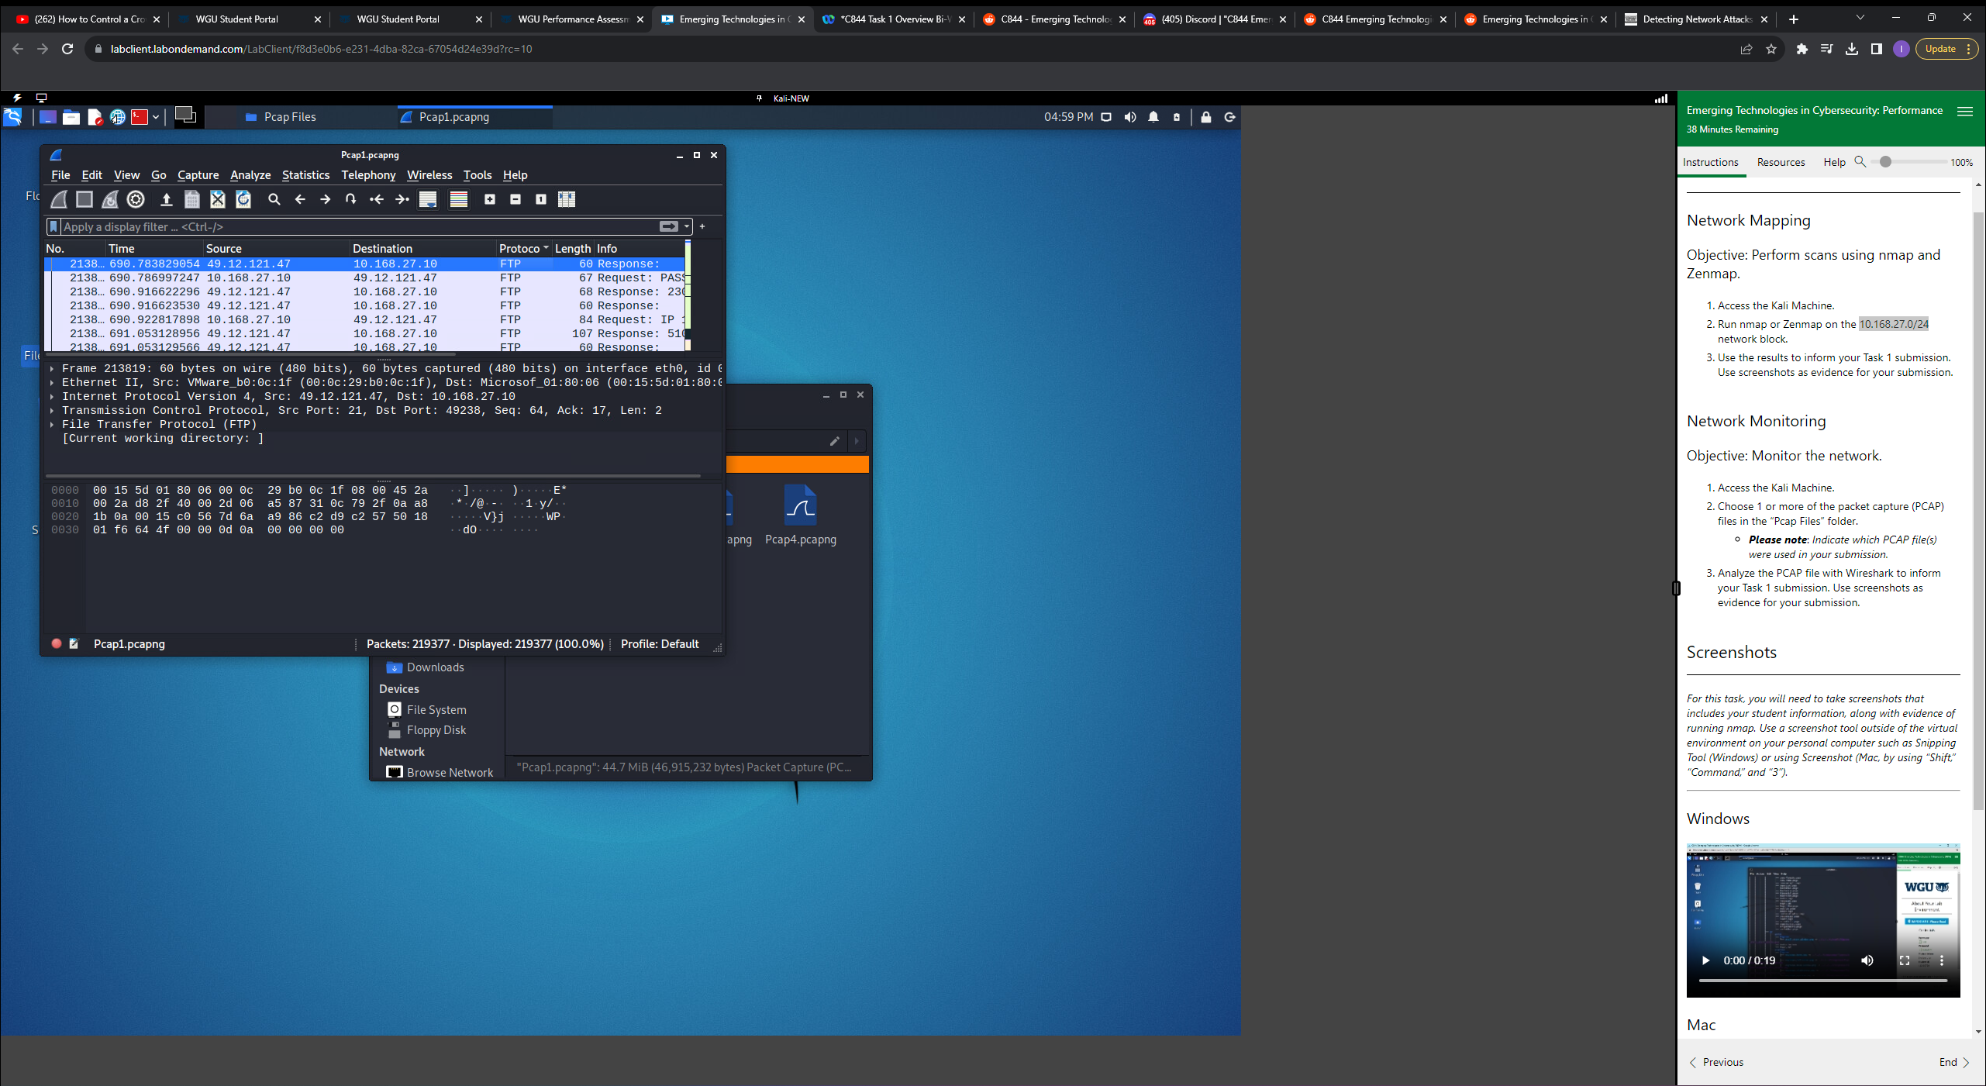

**Second Anomaly**

The host 10.168.27.10 was also sending and receiving web traffic over port 80 using HTTP. HTTP web traffic is not encrypted, so data sent can be intercepted by packet sniffers and used by attackers.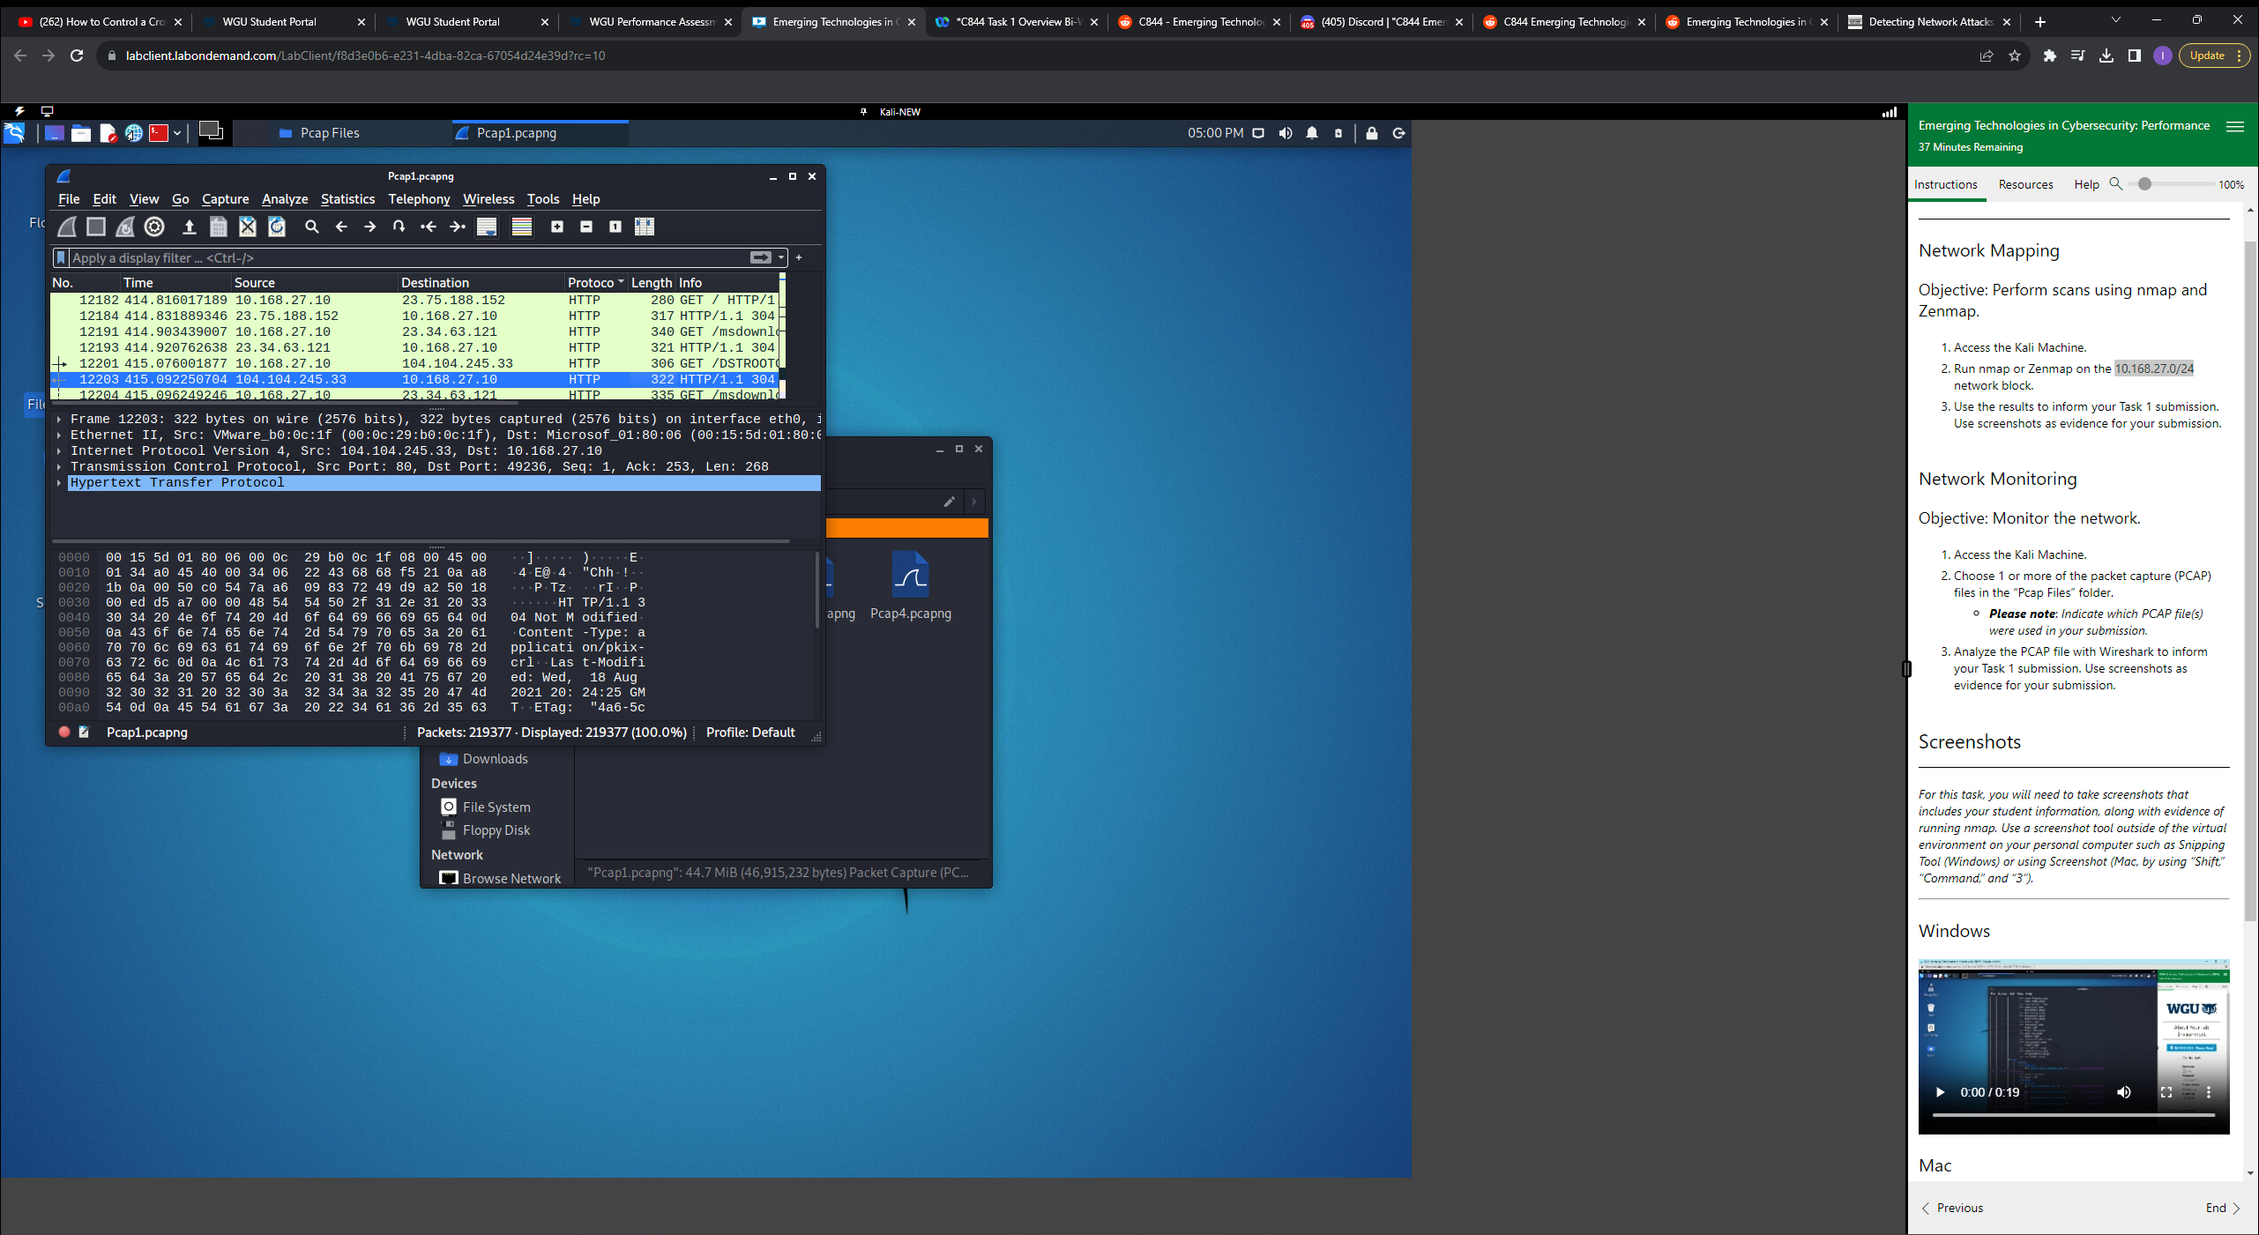

**D. Implications of each Wireshark Anomaly**

The FTP protocol sends data in the clear over port 21 and 20 using plaintext, this means that any data sent between 10.168.27.10 and 49.12.121.47 could be intercepted and read by an attacker. This could possibly lead to login credentials, personal data, and other confidential data being used by said attacker. Especially over port 21, which is used for FTP control traffic.

**Implications of taking no action 2**

The host 10.168.27.10 using unencrypted HTTP web traffic over port 80 means that any data exchanged from other hosts or web servers could be intercepted by packet sniffers and other tools. This could potentially let an attacker obtain session cookies, login credentials, and other sensitive data during a web session. Which could ultimately lead to data theft, unauthorized access, and other security breaches.

**E. Recommended Solutions**

**First Vulnerability**

A solution to data transfers using FileZilla over port 21 using FTP would be to simply enable FTPS and SFPT on FileZilla, because it supports both (VELAN, 2023). This would encrypt the files exchange by hosts using FileZilla, lowering the attack surface.

**Second Vulnerability**

Windows Server 2008 is an outdated legacy OS that is no longer supported and wide open to attackers. For example, when Microsoft discontinued support for Windows Server 2003, it caused a slew of problems “It created a field day for internet hackers. In July 2015, hackers just needed to wait to find new vulnerabilities in Windows Server 2003. Once discovered, the hackers knew that many of the systems running that operating system would not have patches to fix the problem” (Young, 2019). Windows Server 2008, no longer supported as of 2020, is subjected to the same scrutiny as its older counterpart Windows Server 2003. The solution to this would be to upgrade to a supported OS that receives regular patches, either Windows Server 2019 or Windows Server 2022.

**First Anomaly**

A Host in the network was exchanging unencrypted data to another host outside of the network using FTP over port 21. “Legacy FTP traffic that is transmitted over TCP port 21 is not a secure protocol. Files, credentials, and other information traversing FTP are transmitted in cleartext with no encryption” (Lee, 2022). Since ports operate on OSI layer 4 and switches operate on OSI layer 2, you could not block the port on the switch. However, you can block the port on the host, which would stop outbound and inbound FTP traffic on the host.

**Second Anomaly**

HTTP sends unencrypted plaintext web data over port 80, which makes it very unsecure “If you aren't running over an HTTPS connection your username and password are sent in clear text over the internet” (Jackson, 2021). A way to mitigate this would be to migrate to HTTPS over port 443. HTTPS uses TLS/SSL to encrypt web traffic making it very secure.

**References**

**Jackson, B. (2022, December 21). How to Migrate from HTTP to HTTPS - Complete Guide. Retrieved August 30, 2023, from https://www.keycdn.com/blog/http-to-https**

**Lee, B. (2022, January 31). TCP port 21 FTP vulnerabilities. Specopssoft. Retrieved August 30, 2023, from** [**https://specopssoft.com/blog/tcp-port-21-ftp-**](https://specopssoft.com/blog/tcp-port-21-ftp-)**vulnerabilities/#:~:text=For%20example%2C%20legacy%20FTP%20traffic,the%20bad%20guys%20concerning%20ransomware.**

**Young, P. (2019, October 23). Risks of Running Unsupported Windows 2008. Datavail. Retrieved August 30, 2023, from https://www.datavail.com/blog/risks-of-running-unsupported-windows-2008/**

**V. (n.d.). How To Configure FTPS Using Filezilla FTP Server? Velan Info. Retrieved August 30, 2023, from https://velaninfo.com/rs/techtips/how-to-configure-ftps-using-filezilla-ftp-server/**